Quiz_Lecture16

Name：刘承奇 Student ID：2018533249

According to this slide, explain why adaboost keeps decreasing testing error, even if training error equals to zero?

We have that:

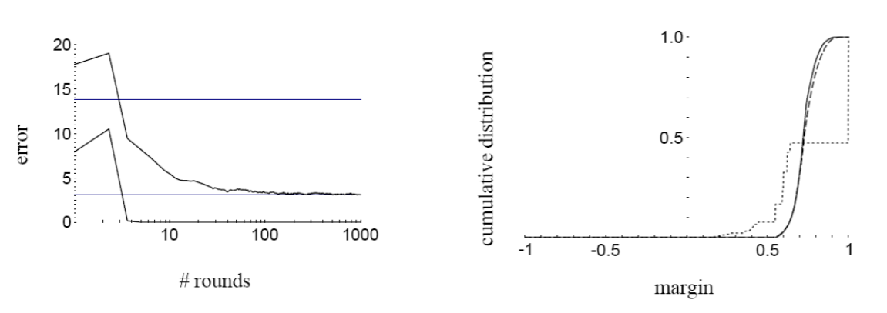

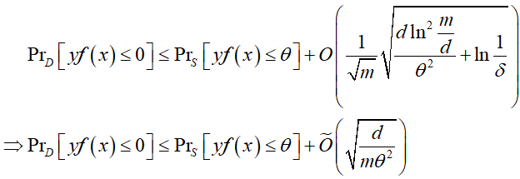

In the formula before, we have that 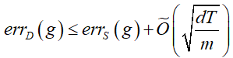. So, we guess that when the round T increases, the testing error will also increase finally.

But in this new formula, 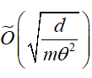 has nothing to do with T, so the testing error won’t increase when T increase. If we fix the error rate, as we learn, the margin θ will increase, then the testing error will decrease. So, even if training error equals to zero, the adaboost can also keep decreasing testing error.